

THE CORPORATION OF THE
MUNICIPALITY OF SIOUX LOOKOUT
Request for Quotation (RFQ) No. Q033-2026
Snow Clearing and Sanding Services - Winter 2026-2027

Issue Date | October 13, 2026
Optional Site Visit | By appointment only. Must be confirmed in advance with Jeff Hawley. Requests by October 14, 2026; visits available through October 16, 2026.
Deadline for Questions | October 20, 2026, at 4:00 PM Central Time
Anticipated Final Addendum | October 23, 2026
Closing Date and Time | October 28, 2026, at 2:00 PM Central Time
Anticipated Award | Week of November 2, 2026
Service Commencement | Upon execution, anticipated November 9, 2026
Initial Contract Term | From execution through May 15, 2027
Owner | The Corporation of the Municipality of Sioux Lookout

Prepared by:
Public Works Department
The Corporation of the Municipality of Sioux Lookout
41 Fifth Avenue
Sioux Lookout, ON, P8T 1A4

Contents
1.2 Procurement Objectives 4
1.3 Service Parts and Award Flexibility 4
1.4 Contract Term 4
1.5 Procurement Schedule 4
1.6 Definitions 5
Part 2 - Instructions to Bidders 5
2.1 Single Point of Contact and No Lobbying 5
2.2 Questions and Addenda 6
2.3 Optional Site Visit and Due Diligence 6
2.4 Quotation Validity 6
2.5 Costs of Quotation 6
2.6 Confidentiality and MFIPPA 6
2.7 Conflict of Interest 6
2.8 Subcontractors 6
2.9 Alternative Quotations 7
Part 3 - Background and Winter Maintenance Context 7
3.1 Community and Operating Context 7
3.2 Service Part A - Municipal Parking Lots and Facilities 7
3.3 Service Part B - Urban Snow Clearing 7
3.4 Operational Route Phasing and Maps 7
3.5 Information Provided to Bidders 7
Part 4 - Scope of Services 7
4.1 General Contractor Responsibilities 7
4.2 Roads, Back Lanes and Cemetery Roads 8
4.3 Sidewalks, Pedestrian Routes and Walking Trail 8
4.4 Accessibility-Program Driveway Windrows 8
4.5 Snowbank Removal, Snow Placement and Hauling 8
4.6 Sanding and Ice Control 8
Part 5 - Staffing, Equipment, Service Levels, Safety and Emergency Response 8
5.1 Twenty-Four-Hour Availability and Weather Monitoring 8
5.2 Service Triggers, Priorities and Completion Standards 8
5.3 Minimum Equipment and Backup Capacity 9
5.4 Operators, Supervision and Competency 9
5.5 Health and Safety 9
5.6 Damage Prevention, Reporting and Repair 9
5.7 Minimum Performance Indicators 10
Part 6 - Records, Communication and Quality Control 10
6.1 Service Records 10
6.2 Communication and Complaints 10
6.3 Inspection, Deficiencies and Corrective Work 10
6.4 Municipality Responsibilities 10
Part 7 - Quotation Submission Requirements 11
7.1 Submission Structure 11
7.2 Experience and References 11
7.3 Equipment and Backup Information 12
7.4 Winter Operations Plan 12
7.5 Assumptions, Exclusions and Qualifications 12
Part 8 - Evaluation and Award 12
8.1 General 12
8.2 Stage 1 - Mandatory Requirements 12
8.3 Stage 2 - Capability and Responsibility Review (Pass/Fail) 12
8.4 Stage 3 - Price Evaluation and Award 13
8.5 Clarifications / Interviews / Due Diligence 13
8.6 Award and Agreement 13
Part 9 - Commercial and Contract Administration Requirements 13
9.1 Pricing Basis 13
9.2 No Guaranteed Quantities 13
9.3 Invoicing and Payment 13
9.4 Insurance and WSIB 14
9.5 Indemnity, Default and Municipal Step-In 14
9.6 Termination and Transition 14
9.7 Changes and Additional Work 14
Part 10 - Rights of the Municipality 14
Appendix A - Service Part A Municipal Parking Lots and Facilities 15
Appendix A-1 - Municipal Parking Lot Snow Removal Map 16
Appendix B - Service Part B Urban Roadway Inventory and Classifications 17
Appendix C - Urban Snow Clearing Priority Routes and Maps 19
Appendix D - Mandatory Pricing Form 30
Appendix E - Equipment and Capacity Schedule 31
Appendix F - Quotation Response Schedule 32
Appendix G - Form of Services Agreement 33
Appendix H - Bidder Declaration, Addenda Acknowledgement and Submission Checklist 35

Part 1 - Invitation and Key Procurement Information

1.1 Invitation
The Corporation of the Municipality of Sioux Lookout (the "Municipality") invites quotations from experienced and qualified winter-maintenance contractors to provide snow clearing, plowing, snow removal, sanding and related services for the 2026-2027 winter season as described in this RFQ.
The Municipality requires reliable equipment, trained and competent operators, sufficient primary and backup capacity, twenty-four-hour response capability, effective communications, and complete service records. Bidders may submit for Service Part A, Service Part B, or both.

1.2 Procurement Objectives
- provide safe, reliable and timely winter maintenance for municipal roads, back lanes, sidewalks, walking trails, parking lots and facility access areas;
- meet or exceed the applicable Minimum Maintenance Standards for Municipal Highways under Ontario Regulation 239/02, as amended, together with any higher service level expressly established by the Municipality;
- maintain dependable twenty-four-hour mobilization, operator and backup-equipment capacity throughout the contract term;
- provide consistent route execution, documentation, communication and quality control during continuing and severe winter events;
- obtain transparent and comparable pricing while preserving the Municipality's ability to award Service Part A and Service Part B separately or together; and
- reduce service disruption risk arising from equipment breakdown, absenteeism, overlapping work or severe winter conditions.

1.3 Service Parts and Award Flexibility
The procurement is divided into the following independent service parts:
- Service Part A - Municipal Parking Lots and Facilities: snow clearing and sanding at the municipal facilities identified in Appendix A.
- Service Part B - Urban Snow Clearing: comprehensive snow clearing throughout the Urban Service Area, including roads, all municipally maintained back lanes, municipal sidewalks and pedestrian routes, the identified walking trail, cemetery roads, accessibility-program driveway windrows, and directed snowbank removal.
- Optional Part B Sanding and Ice Control: urban roadway, back-lane, sidewalk, pedestrian-route and walking-trail sanding may be awarded with Part B or retained by the Municipality.
A Bidder may submit for Part A only, Part B only, or both. The Municipality may award the Parts separately to different Bidders, award both Parts to one Bidder, award only one Part, retain optional Part B sanding in-house, or reject any or all Quotations in accordance with this RFQ and applicable procurement requirements.

1.4 Contract Term
The anticipated Service Commencement is November 9, 2026, subject to completion of the procurement, award and execution of the Services Agreement. The Initial Contract Term will continue through May 15, 2027, unless terminated earlier under the Agreement. The Municipality may, by mutual written agreement and subject to satisfactory performance, budget authorization and applicable procurement requirements, extend the Agreement for one additional winter season or part of a winter season.

1.5 Procurement Schedule
The anticipated procurement schedule is shown on the cover page. The Municipality may amend the schedule by addendum. The RFQ and any subsequently issued addenda govern the procurement schedule. All times are Central Time.
Milestone | Date / Requirement
Issue Date | October 13, 2026
Optional Site Visit | By appointment only; confirmed in advance with Jeff Hawley. Requests by October 14, 2026; visits available through October 16, 2026.
Deadline for Questions | October 20, 2026, at 4:00 PM Central Time
Anticipated Final Addendum | October 23, 2026
Closing Date and Time | October 28, 2026, at 2:00 PM Central Time
Anticipated Award | Week of November 2, 2026
Anticipated Service Commencement | November 9, 2026
Contract End | May 15, 2027

1.6 Definitions
Term | Meaning
Contractor | The successful Bidder that enters into the Services Agreement with the Municipality.
Bidder | A firm or individual submitting a Quotation in response to this RFQ.
MMS | The Minimum Maintenance Standards for Municipal Highways under Ontario Regulation 239/02, as amended from time to time.
Part A | Municipal parking-lot and facility snow clearing and sanding described in Appendix A.
Part B | Urban snow clearing described in this RFQ, Appendix B and Appendix C.
Winter Event | A snowfall, drifting, freezing, freeze-thaw or related winter condition requiring service under the Contract or Municipal direction.
Full Clearing Event | For Part B pricing and payment purposes, one complete clearing assignment for the applicable service component arising from a Winter Event, including the passes reasonably required to complete the assigned routes to the required service standard following that event. Re-clearing specifically directed by the Municipality after completion because of a subsequent distinct Winter Event may constitute a new Full Clearing Event.
Business Day | A day other than Saturday, Sunday or a statutory holiday in Ontario.

Quotation means the complete submission delivered by a Bidder in response to this RFQ, including all forms, schedules, attachments, pricing, declarations and written clarifications accepted by the Municipality.
Work means all labour, services, supervision, equipment, materials, records and other obligations required to perform an awarded Service Part under the Contract.

Part 2 - Instructions to Bidders

2.1 Submission Method, Receiving Officer, Procurement Contact and No Lobbying
Quotations shall be submitted as sealed physical submissions and must be received before the Closing Date and Time. Email, fax and other electronic Quotation submissions will not be accepted.
Each Quotation shall consist of one (1) signed original placed in a sealed envelope or package. The outer envelope or package shall clearly show the Bidder name and return address and shall be marked:
RFQ Q033-2026 - Snow Clearing and Sanding Services - Winter 2026-2027
DO NOT OPEN BEFORE 2:00 PM CENTRAL TIME, OCTOBER 28, 2026
Physical submissions shall be addressed and delivered to:
Ashley McLean
Deputy Clerk, Corporate Services Department
The Corporation of the Municipality of Sioux Lookout
PO Box 158
25 Fifth Avenue
Sioux Lookout, ON P8T 1A4
The Quotation must be received at the Municipal Office, 25 Fifth Avenue, Sioux Lookout, no later than 2:00 PM Central Time on October 28, 2026. The Bidder is solely responsible for ensuring that a mailed, couriered or hand-delivered Quotation arrives before the deadline. The Municipality is not responsible for postal, courier or delivery delays. The official receipt time recorded by Corporate Services will govern. Late Quotations will not be considered and may be returned unopened, subject to the Municipality's procurement requirements.
Corporate Services will date- and time-stamp received submissions and hold them unopened until after the Closing Date and Time. Ashley McLean is the receiving officer for physical submissions only and is not the Procurement Contact. All questions, site-visit requests and other communications regarding this RFQ shall be directed only through the procurement posting or to the Procurement Contact identified below. After Closing, submissions will be opened and recorded in accordance with the Municipality's procurement procedures. Receipt or opening of a Quotation does not constitute acceptance or award.
Jeff Hawley, B.Sc., C.E.T.(ret.)
Public Works Manager, Municipality of Sioux Lookout
Office: 807.737.1234; Cell: 1 (431) 335-7264; Email: jhawley@siouxlookout.ca
Bidders shall not contact members of Council or other Municipal staff to influence the procurement process. Operational discussions during an approved site visit do not amend this RFQ unless confirmed by written addendum. A Bidder may withdraw or replace its Quotation before the Closing Date and Time by written notice to the Deputy Clerk. Any replacement Quotation must be separately sealed, clearly marked and received before Closing. No Quotation may be amended after Closing except through a clarification requested by the Municipality.

2.2 Questions and Addenda
Questions shall be submitted in writing by October 20, 2026, at 4:00 PM Central Time. Responses that affect the RFQ will be issued by addendum to registered document takers. The Municipality anticipates issuing its final addendum by October 23, 2026. Oral statements, site discussions or informal communications do not amend the RFQ.

2.3 Optional Site Visit and Due Diligence
A site visit is optional and is not a condition of Quotation submission or evaluation. Site visits will be arranged by appointment only and must be confirmed in advance with Jeff Hawley. Bidders shall not attend municipal facilities or operational areas for an unconfirmed site visit. Requests for a site visit should be submitted no later than October 14, 2026, with visits to occur no later than October 16, 2026.
The Municipality may determine the locations and duration of an optional visit based on the Service Part or Parts of interest. Bidders are encouraged to review Appendix A and Appendix A-1 before requesting a visit. Bidders are responsible for their own due diligence regarding access, route geometry, clearances, snow-storage constraints, facility conditions and local operating conditions. Information provided orally during a visit does not amend this RFQ unless confirmed by addendum.

2.4 Quotation Validity
Quotations shall remain open for acceptance for a minimum of ninety (90) calendar days following the Closing Date unless a different period is stated by addendum.

2.5 Costs of Quotation
All costs incurred in preparing, submitting, presenting, clarifying or negotiating a Quotation are the Bidder's responsibility. The Municipality will not reimburse quotation costs. This RFQ does not create a commitment by the Municipality to award a contract.

2.6 Confidentiality and MFIPPA
Quotations and records submitted to the Municipality are subject to the Municipal Freedom of Information and Protection of Privacy Act and other applicable law. Bidders shall clearly identify information they consider confidential or proprietary while acknowledging that the Municipality cannot guarantee non-disclosure where disclosure is required by law.

2.7 Conflict of Interest
Bidders shall disclose actual, potential or perceived conflicts of interest and describe proposed mitigation. The Municipality may require additional mitigation or may disqualify a Bidder where a conflict cannot be appropriately managed.

2.8 Subcontractors
Bidders shall identify all proposed subcontractors and the work they would perform, including backup snow-hauling, snowbank removal, sanding or other recurring services. The Contractor remains fully responsible for the performance, safety, records, insurance, WSIB compliance and acts or omissions of approved subcontractors.

2.9 Alternative Quotations
A Bidder may include value-added alternatives only after submitting a fully compliant base Quotation for the applicable Service Part. Alternatives shall be clearly separated, shall not qualify or replace the base Quotation, and shall identify the proposed benefit, risk, scope change and price impact. An alternative shall not reduce a mandatory safety, equipment, response, insurance or service-level requirement.

Part 3 - Background and Winter Maintenance Context

3.1 Community and Operating Context
Sioux Lookout is a northern Ontario municipality with substantial winter snowfall, drifting, freeze-thaw conditions and prolonged cold-weather operations. Winter maintenance must be delivered reliably during overnight, weekend and holiday periods and may require repeated passes during continuing or severe events. The Contractor will work closely with Municipal Public Works staff and shall respond promptly to changing priorities, emergency access needs and localized conditions.

3.2 Service Part A - Municipal Parking Lots and Facilities
Part A covers the parking lots, driveways, entrances, fire routes, loading or service areas and related facility surfaces listed in Appendix A. Appendix A-1 provides a visual location reference. Sanding and ice control performed as part of a clearing event are included in the applicable per-clearing-event price. Stand-alone sanding performed when clearing is not required will be paid at the separate rate quoted in Appendix D. Facility-specific completion priorities are intended to maintain access before normal public opening or scheduled use.

3.3 Service Part B - Urban Snow Clearing
Part B covers the Urban Service Area and includes all municipally maintained roads and back lanes, assigned municipal sidewalks and pedestrian routes, the identified walking trail, cemetery roads shown in Appendix C, accessibility-program driveway windrow removal when directed, and snowbank removal or hauling when required or directed. Every municipally maintained urban back lane is included, whether individually named in Appendix B or captured under the entry "Back Lanes - All Others."

3.4 Operational Route Phasing and Maps
Appendix C contains the Municipality's operational phase maps for roads, sidewalks, walking trail and cemetery roads. Phase I identifies the arterial and hospital route to be completed first. Phase II and Phase III maps identify subsequent road and back-lane routes. Sidewalk and walking-trail maps identify pedestrian routes and sand-box locations. The Municipality may revise sequencing or priority during a Winter Event to address public safety, emergency access, drifting, equipment availability, local conditions or other operational needs.
Where an operational map shows a municipally maintained route that is not separately named in Appendix B, the mapped route is included in the applicable Part B scope unless the Municipality directs otherwise in writing.

3.5 Information Provided to Bidders
The appendices form the primary service information package for this procurement. Bidders are responsible for reviewing the facility list, roadway inventory, classifications, route maps, sidewalk and trail maps, pricing forms and equipment requirements and for identifying any material clarification request during the question period.

Part 4 - Scope of Services

4.1 General Contractor Responsibilities
The Contractor shall supply all labour, supervision, qualified operators, vehicles, equipment, backup equipment, fuel, maintenance, communications, safety equipment and incidentals required to perform the awarded Work, except where this RFQ expressly states otherwise. The Contractor shall organize its resources so that foreseeable winter weather, equipment breakdown, operator absence and overlapping assignments do not interrupt required service.
- maintain twenty-four-hour contact and mobilization capability throughout the Contract Term;
- monitor forecasts, accumulation, drifting, freezing conditions and assigned road, sidewalk, trail and facility conditions;
- make repeated passes during continuing or severe events and deploy backup resources when required;
- prioritize emergency routes, the arterial and hospital route, steep grades, intersections, higher-volume roads, high-use facilities and pedestrian routes as directed;
- promptly correct missed sections, unsafe ridges, blocked entrances or curb ramps, excessive narrowing and other deficiencies within the awarded scope; and
- maintain accurate daily operational records sufficient to demonstrate the work completed and compliance with service requirements.

4.2 Roads, Back Lanes and Cemetery Roads
Clear roads, back lanes and cemetery roads to the width and condition required by the applicable MMS, the route maps and Municipal direction. Operations shall preserve access for emergency vehicles, refuse collection, residents, businesses and ordinary traffic. Back-lane service includes plowing or grading, intersections and entrances, turning areas where present and corrective passes needed to maintain safe access.
Snow shall not be placed where it blocks intersections, traffic-control devices, railway crossings, fire hydrants, catch basins, culverts, utility access points, building entrances, driveways, sidewalks, required sightlines or drainage paths. Part B roadway work will generally continue until the applicable route phase is complete and should be completed within the applicable MMS and, where practicable, within approximately twenty-four hours after the end of the Winter Event, subject to event severity and Municipal direction.

4.3 Sidewalks, Pedestrian Routes and Walking Trail
Plow and, where necessary, blow snow from assigned municipal sidewalks, curb ramps, crossings, pedestrian connections and the walking trail shown in Appendix C. Equipment and operating methods shall avoid damage to curbs, sidewalks, signs, landscaping and street furniture. Where optional Part B sanding is awarded, assigned pedestrian routes shall receive ice control as required by the MMS or Municipal direction.

4.4 Accessibility-Program Driveway Windrows
The Municipality will provide and update the list of approved properties. Windrows shall be removed only when directed and on an as-needed basis during the winter. The Contractor shall clear the full usable width of the driveway entrance, avoid depositing snow on sidewalks or neighbouring properties, and record each address and completion time. The approved-property list is confidential and shall be used only to perform the Contract.

4.5 Snowbank Removal, Snow Placement and Hauling
Perform winging back, benching, blowing, loading, hauling and approved disposal when directed or when necessary to maintain applicable service requirements. Priority shall be given to restricted sightlines, narrowed travel lanes, intersections, pedestrian areas, drainage concerns and locations with exhausted snow-storage capacity. Snow shall be stored or disposed of only in locations approved by the Municipality and shall not be pushed onto private property without authorization.

4.6 Sanding and Ice Control
Part A sanding and ice control are included. After plowing, during freezing conditions or when directed, the Part A Contractor shall apply Municipality-approved traction or de-icing material to parking lots, driveways, entrances, accessible parking and access aisles, and other assigned facility surfaces. Stand-alone sanding shall be available when plowing is not required.
Part B sanding and ice control are optional and severable. If retained and awarded, the Contractor shall apply approved material to roads, back lanes, sidewalks, curb ramps, crossings, the walking trail and other assigned locations as required by the MMS or Municipal direction. Calibrated spreading equipment shall be used and records shall identify the route or location, start and completion times, surface condition, material, application rate or quantity, equipment and operator.

Part 5 - Staffing, Equipment, Service Levels, Safety and Emergency Response

5.1 Twenty-Four-Hour Availability and Weather Monitoring
The Contractor shall maintain a designated twenty-four-hour contact and alternate throughout the Contract Term. The Contractor shall monitor forecasts and developing conditions and shall advise the Public Works Manager or Operations Supervisor immediately of a condition that may affect service compliance, public safety, completion times or equipment availability.

5.2 Service Triggers, Priorities and Completion Standards
For Part B, snow clearing shall be initiated for a Winter Event that meets or exceeds the applicable MMS threshold or whenever directed by the Operations Supervisor or Public Works Manager. All Part B Work shall meet or exceed applicable MMS requirements, including roadway and sidewalk classifications, snow-depth thresholds, treatment and clearing timeframes and recordkeeping obligations.
For Part A, parking-lot and facility snow clearing shall begin when accumulation reaches approximately 7.5 centimetres, or earlier when directed. The completion priorities in Appendix A apply unless revised by the Municipality based on facility use, drifting, freezing or public-safety conditions.
During a continuing or severe event, repeated passes and additional or backup resources shall be deployed as reasonably necessary to achieve MMS, or through approval during the event, by the Municipality. Ordinary winter weather, forecast snowfall, cold temperatures, drifting and freezing snow are foreseeable and do not, by themselves, excuse performance.

5.3 Minimum Equipment and Backup Capacity
The Contractor shall provide sufficient primary and backup equipment to complete the awarded Work within required timeframes. At minimum, the following equipment shall be dedicated or immediately available for Part B:
- a grader sized and configured to safely and effectively service back lanes;
- a grader suitable for main-road snow clearing, with a larger unit preferred where practical;
- a loader suitable for snowbank cutting, loading, relocation and cleanup;
- a sidewalk plow and a sidewalk-capable unit fitted with a snow blower, or a multi-purpose unit capable of both functions without delaying service;
- trucks or other hauling equipment sufficient for directed snowbank removal;
- reliable cellular or two-way communications for every active unit; and
- if optional Part B sanding is awarded, calibrated roadway and sidewalk sanding equipment.
Part A Bidders shall provide sufficient lot-clearing, loading and sanding equipment to complete all awarded facilities within their required timeframes. Every Bidder shall identify primary and backup units in Appendix E.

5.4 Operators, Supervision and Competency
Equipment shall be mechanically sound, properly licensed and insured, fitted with required lighting and warning devices and maintained in safe operating condition. Operators shall be appropriately licensed, trained, rested and competent in winter-maintenance operations and hazard awareness. The Contractor shall maintain sufficient qualified relief and backup operators to cover breakdowns, absenteeism, illness, fatigue management and overlapping work.

5.5 Health and Safety
The Contractor is responsible for the health and safety of its workers and subcontractors and shall comply with the Occupational Health and Safety Act and all other applicable law. The Contractor shall maintain appropriate procedures for traffic protection, safe reversing, working alone, fatigue management, personal protective equipment, equipment inspection, public interaction and incident response.

5.6 Damage Prevention, Reporting and Repair
Before operations begin, the parties should document known hazards and pre-existing damage in vulnerable areas. The Contractor shall use appropriate markers, equipment and operating methods and shall take reasonable precautions around curbs, boulevards, sidewalks, signs, hydrants, utilities, mailboxes, landscaping, buildings, vehicles and private property.
The Contractor shall immediately report any collision, injury, property damage, environmental release or public-safety incident. Minor damage arising from the Contractor's operations shall be remedied within thirty (30) days after notice. Damage that, in the opinion of the Municipality, poses a risk to motorists or pedestrians shall be repaired within seventy-two (72) hours after notice or within another timeframe directed by the Municipality. Immediate temporary protection shall be installed when required.

5.7 Minimum Performance Indicators
Performance Area | Minimum Expectation | Reporting / Escalation
24/7 contact and mobilization | Continuous availability throughout Contract Term | Immediate notice of any gap or breakdown affecting service
Part A clearing trigger | Approximately 7.5 cm or earlier when directed | Complete facilities in Appendix A priority order
Part B snow clearing | Meet or exceed applicable MMS and Municipal direction | Route/service record for each event
Continuing/severe events | Repeated passes and backup deployment as required | Escalate material delay or resource constraint immediately
Equipment breakdown | Replacement or recovery plan without material service interruption | Report immediately where completion may be affected
Service records | Complete, legible and sufficient to demonstrate work performed | Provide daily, weekly or on request
Critical incident / damage | Immediate protection and notification | Written follow-up as requested by Municipality

Part 6 - Records, Communication and Quality Control

6.1 Service Records
The Contractor shall maintain complete, legible records sufficient to demonstrate compliance with the Contract and applicable MMS. Records shall be provided daily, weekly or on request and retained for at least seven (7) years after the end of the winter season, or longer where required by law or written Municipal direction. Records shall include, at minimum:
- date, route or location, dispatch time, start time and completion time;
- weather and surface conditions, snow depth and drifting observations where applicable;
- work performed, equipment, operator, materials, quantities and application rates where applicable;
- interruptions, hazards, complaints, deficiencies and corrective actions; and
- GPS or automated vehicle-location data when available or required by the accepted Quotation.

6.2 Communication and Complaints
Directions from the Operations Supervisor or Public Works Manager may be given verbally when immediate action is required and confirmed in writing afterward where appropriate. The Contractor shall refer media inquiries and formal public complaints to the Municipality and shall provide factual operational information and records needed for follow-up. Personal information, including accessibility-program addresses, shall be protected and used only to perform the Contract.
Coordination: Day-to-day coordination of plowing and sanding services will be managed by Dianna Lorteau, Operations Supervisor, Public Works, or, when she is unavailable, Jeff Hawley, Manager of Public Works. All service notifications, call-outs and completion confirmations shall be directed to Dianna Lorteau; if she is unavailable, the Contractor shall contact Jeff Hawley. Contact information will be provided at the time of award. In most cases, the Contractor shall automatically proceed to clear the designated sites when snowfall meets the applicable service trigger. For less severe weather or special circumstances, the Municipality will issue a call-out or confirm whether service is required. For major snowfalls, the Contractor shall respond and mobilize within four (4) hours after a call-out, with a faster response for high-priority locations where necessary to meet required opening deadlines.

6.3 Inspection, Deficiencies and Corrective Work
The Municipality may inspect the Work and records at any reasonable time. Inspection, direction or payment does not relieve the Contractor of responsibility for complete and compliant performance. Missed sections, unsafe ridges, blocked entrances or curb ramps, excessive narrowing, improper snow placement or other deficiencies within the awarded scope shall be corrected promptly and at no additional cost where the correction is required to complete the originally assigned Work.

6.4 Municipality Responsibilities
- provide the Appendix A facility requirements, Appendix B roadway inventory and classifications, Appendix C operational route maps and approved snow-storage or disposal locations;
- provide the current list of approved accessibility-program properties for Part B where required;
- designate the Public Works Manager, Operations Supervisor or another contract administrator to issue directions, receive records, communicate deficiencies and oversee performance; and
- retain responsibility for non-delegable statutory duties while requiring the Contractor to perform its contractual obligations to the specified service level.

Part 7 - Quotation Submission Requirements

7.1 Submission Structure
Each Quotation shall be provided as one (1) signed original in the sealed physical submission required by Section 2.1. Bidders should avoid unnecessary promotional material and should use clear section dividers or headings so the evaluation team can readily locate the required information. After Closing, the Municipality may scan or reproduce the Quotation for administrative and evaluation purposes.
Quotations shall be concise, complete and organized in the order below. Pricing shall be submitted only in the prescribed pricing forms. The Municipality may reject a Quotation, deem it non-compliant, or exclude non-comparable pricing where material assumptions, qualifications or omissions prevent a fair comparison.
Section | Required Content
A. Corporate Experience | Relevant winter-maintenance experience, local or regional operating base and three references.
B. Understanding and Winter Operations Methodology | Approach to mobilization, route phasing, continuing events, snowbank removal, sanding, facility priorities and quality control.
C. Equipment and Backup Capacity | Completed Appendix E, including make/model/year/capacity, primary and backup status, ownership/lease status and normal mobilization location.
D. Staffing, Supervision and Communications | Operator availability, supervision, relief coverage, fatigue management, 24/7 contact and communication approach.
E. Recordkeeping and Safety | Service records, GPS/AVL capability where available, complaint/deficiency tracking, safety program and incident reporting.
F. Pricing | Completed Appendix D, including all applicable unit prices for the Service Part or Parts proposed.
G. Assumptions / Exceptions / Subcontractors | All assumptions, qualifications, exceptions and proposed subcontractors, with impacts clearly identified.
H. Declarations | Completed Appendix H, addenda acknowledgement, insurance/WSIB confirmation and submission checklist.

7.2 Experience and References
Bidders shall demonstrate recent experience with municipal, commercial, institutional or comparable winter-maintenance services of similar scale and operating conditions. The Municipality will consider whether the submitted experience and references demonstrate the capacity to perform the quoted scope reliably, including work involving northern-winter conditions, multiple route classes, pedestrian routes, snowbank removal and severe-event response where applicable.

7.3 Equipment and Backup Information
Every proposed primary and backup unit shall be identified in Appendix E. The Municipality may request proof of ownership, lease, availability, inspection, licensing, insurance or capacity. Proposed substitutions after award require prior Municipal approval and shall provide equal or better capability.

7.4 Winter Operations Plan
The Bidder shall provide a concise winter operations plan addressing mobilization, the Appendix C route phases, staffing and supervision, relief and fatigue management, continuing/severe-event response, equipment breakdown and backup resources, snowbank removal and hauling, communication with Municipal staff, quality control and service records.

7.5 Assumptions, Exclusions and Qualifications
All assumptions, exclusions and qualifications affecting scope, risk, service levels, pricing, equipment or responsibility shall be listed in Appendix F. If none, state "None." A material qualification contained elsewhere but omitted from the dedicated schedule may be disregarded by the Municipality for evaluation purposes.

Part 8 - Evaluation and Award

8.1 General
For each Service Part or permitted combination of Service Parts, the Municipality intends to award to the lowest evaluated compliant and responsible Bidder, subject to the rights reserved in this RFQ. Compliance, demonstrated capability to perform the Work, equipment and backup capacity, experience, staffing, safety, recordkeeping and submitted pricing will be reviewed. The Municipality is not bound to accept the lowest-priced Quotation or any Quotation where the submission is non-compliant, the Bidder is not considered capable of performing the Work, or acceptance would not be in the Municipality's best interests in accordance with its procurement requirements.

8.2 Stage 1 - Mandatory Requirements
- sealed physical Quotation received and time-stamped by Corporate Services before the Closing Date and Time in accordance with Section 2.1;
- signed Quotation/declaration and addenda acknowledgement;
- completed Appendix D pricing form for the Service Part or Parts proposed;
- completed Appendix E equipment and backup-capacity schedule;
- confirmation of twenty-four-hour contact and mobilization capability;
- proof of, or commitment to obtain, the required insurance and WSIB coverage;
- required experience, reference and operations-plan information; and
- no material qualification that defeats a mandatory service, safety, equipment or response requirement.
Failure to satisfy a mandatory requirement may result in the Quotation being deemed non-compliant and not proceeding to the capability, responsibility or price review.

8.3 Stage 2 - Capability and Responsibility Review (Pass/Fail)
Criterion | Review | What Will Be Verified
Relevant experience and references | Pass / Fail | Comparable winter services, northern conditions, municipal/public-sector work, satisfactory references and demonstrated performance.
Primary and backup equipment capacity | Pass / Fail | Suitability, quantity, operating condition, availability, backup depth, mobilization location and ability to service the quoted scope.
Winter operations plan and mobilization approach | Pass / Fail | Understanding of route phases, facility priorities, continuing events, snowbank removal, hauling, sanding, communications and quality control.
Staffing, supervision, communications and availability | Pass / Fail | 24/7 contact, operator depth, supervision, relief coverage, fatigue management and reliable communications.
Recordkeeping, quality control and safety approach | Pass / Fail | Service records, GPS/AVL where available, inspection/correction process, safety program and incident reporting.

Stage 2 is a pass/fail responsibility review and is not point-scored. The Municipality will determine whether the Bidder has demonstrated the experience, equipment, backup resources, staffing, supervision, operational approach, safety systems and recordkeeping capability required to perform the Service Part or Parts quoted. A Bidder that does not demonstrate satisfactory capability may be deemed not responsible for the applicable Service Part and may not proceed to price evaluation. The Municipality may clarify minor ambiguities but is not required to permit material quotation repair after Closing.

8.4 Stage 3 - Price Evaluation and Award
Part A and Part B will be evaluated independently. For Part A, the Municipality will calculate an Evaluated Part A Full Clearing Event Price by adding the quoted per-clearing-event prices for all facilities listed in Section D.2. Stand-alone sanding will not form part of the evaluated base Part A price but will be reviewed for completeness, reasonableness and balance. The evaluated total is for bid-comparison purposes only and does not create a guaranteed quantity of Work.
For Part B, the Municipality will calculate an Evaluated Part B Full Clearing Event Price by adding the quoted per-full-clearing-event prices for Urban Roads, All Urban Back Lanes, and Municipal Sidewalks and Pedestrian Routes including the walking trail in Section D.3. If a base item is expressly stated as Included in another base Part B price, it will be treated as $0 for evaluation and remains fully included in the awarded scope. Accessibility-program windrow removal and hourly snow-removal equipment rates will not form part of the evaluated base Part B price but will be reviewed for completeness, reasonableness, balance and potential cost impact. Optional Part B Sanding and Ice Control will not form part of the evaluation of the base Part B award. Subject to this RFQ and the Municipality's reserved rights, the lowest evaluated compliant Quotation from a responsible Bidder will normally be selected for each Part. If the same Bidder is selected for both Parts, the Municipality may award both Parts under one Agreement. The Municipality may correct obvious arithmetic extensions in accordance with its procurement requirements. A materially unbalanced, incomplete, conditional or non-comparable pricing submission may be rejected. If a quoted price appears abnormally low or contains an apparent error, the Municipality may seek written clarification without permitting the Bidder to revise its competitive price after Closing, except as allowed by applicable procurement requirements.

8.5 Clarifications / Interviews / Due Diligence
The Municipality may conduct clarification, reference verification, equipment inspection or other due diligence with one or more Bidders, including the lowest evaluated compliant Bidder. The Municipality may request confirmation of equipment availability, staffing, insurance, WSIB, subcontractor arrangements, local mobilization and response capability. Clarification shall not be used to permit a material change to a Quotation or provide an unfair competitive advantage.

8.6 Award and Agreement
Award is subject to approval by the appropriate Municipal authority, satisfactory due diligence and execution of the Form of Services Agreement in Appendix G. The RFQ, addenda, accepted Quotation commitments, accepted pricing and written clarifications will be incorporated into the executed Agreement in the stated order of precedence.

Part 9 - Commercial and Contract Administration Requirements

9.1 Pricing Basis
All prices shall be entered in Appendix D, shall exclude HST unless expressly stated otherwise and shall remain firm for the Initial Contract Term unless changed in writing. A Bidder shall clearly state whether an item is included in another price and shall not duplicate charges for the same service. No fuel surcharge, mobilization surcharge or other additional charge may be applied unless expressly identified and accepted in the awarded pricing.

9.2 No Guaranteed Quantities
No minimum number of Winter Events, hours, facility passes, sanding applications, windrow removals, snow-hauling assignments or equipment hours is guaranteed unless a guaranteed quantity or seasonal price is expressly accepted in writing. The Municipality will pay only for authorized and satisfactorily completed services in accordance with the accepted pricing.

9.3 Invoicing and Payment
Invoices shall be submitted monthly and shall itemize service dates, routes or locations, Work performed, applicable unit or hourly rates, materials where applicable and corresponding service records. The Municipality's standard payment term is net thirty (30) days after receipt of an accurate and undisputed invoice. The Municipality may withhold disputed amounts while paying undisputed amounts.

9.4 Insurance and WSIB
- Commercial General Liability insurance of not less than $5,000,000 per occurrence, including winter road maintenance, snow clearing, snow hauling and sanding operations, with the Municipality named as an additional insured;
- Automobile Liability insurance of not less than $2,000,000 per accident for licensed vehicles used in the Work;
- current Ontario Workplace Safety and Insurance Board coverage and clearance certificates; and
- any additional coverage reasonably required by law or the Municipality's insurer for the awarded Work.

9.5 Indemnity, Default and Municipal Step-In
The Contractor shall indemnify and hold harmless the Municipality, its elected officials, officers, employees and agents from third-party claims, losses, costs or damages to the extent caused by the Contractor's negligent act or omission, wilful misconduct or breach of the Contract, including the acts or omissions of its employees, agents and subcontractors.
Where delay or deficient performance creates an actual or potential public-safety risk, the Municipality may arrange alternate forces without waiting for a normal cure period and may recover or set off the reasonable resulting costs where the need for alternate forces arises from Contractor default or failure to maintain required resources.

9.6 Termination and Transition
The Municipality may terminate all or part of the Agreement without cause on thirty (30) days written notice. The Municipality may terminate for material default where the Contractor fails to cure within the period stated in the notice, repeatedly misses required service levels, lacks required equipment or insurance, becomes insolvent, provides a false compliance declaration or commits serious misconduct or a legal violation. On termination or expiry, the Contractor shall provide all outstanding service records and cooperate in an orderly transition.

9.7 Changes and Additional Work
A change to scope, price, term or another material requirement is binding only if documented in writing and authorized by the parties. Operational directions within the agreed scope do not require a formal amendment. Work outside the awarded scope requires prior authorization except where immediate action is expressly directed to address an urgent public-safety condition.

Part 10 - Rights of the Municipality
Without limiting rights available at law or under the Municipality's procurement policy, the Municipality reserves the right to:
- reject any or all Quotations or cancel, amend or reissue the procurement;
- waive minor irregularities that do not create unfairness or materially affect price, scope or competition;
- seek clarification or verification of Quotation information;
- conduct reference checks and inspect proposed equipment or mobilization arrangements;
- seek clarification or verification from a Bidder without permitting a material post-closing change or unfair competitive advantage;
- award Part A and Part B separately or together;
- retain optional Part B sanding and ice control in-house;
- approve or reject material subcontractors;
- require replacement of proposed equipment or personnel where legitimate capability, safety or performance concerns exist; and
- protect the integrity, fairness and best interests of the Municipality throughout the procurement.
The exercise of these rights will be subject to applicable law, the Municipality's procurement requirements and the duty to conduct the process fairly.

Appendix A - Service Part A Municipal Parking Lots and Facilities
A Bidder may quote Part A independently or together with Part B. The successful Part A Contractor is responsible for the following parking lots, driveways, access areas and related facility surfaces. Sanding and ice control are included in the Part A clearing price unless the pricing form expressly provides otherwise. Appendix A-1 provides a visual location reference; the written facility descriptions and requirements in this Appendix govern in the event of any discrepancy.
Facility | Location | Priority | Requirement
Municipal Office / Town Hall | 25 Fifth Avenue | Highest | Main lot and driveways; target completion approximately 7:30 a.m. on business days.
Recreation Centre | 85 King Street | Highest | Main lot and entrances; clear before 6:00 a.m. weekdays and 9:00 a.m. weekends.
Hugh Allen Clinic | 79 Fifth Avenue North | High | Parking areas; target completion before approximately 8:00 a.m. weekdays.
Municipal Lot Adjacent to Red Apple | Front Street | High | Public lot between the Hub and Red Apple; clear early, ideally before 8:00 a.m.
Heritage Railway Station | Station property | High | Include rear portion serving Public Health Unit and Legal Aid; clear before approximately 8:30 a.m.
Centennial Centre Rear | Community centre | High | Rear parking area; clear before weekday opening or scheduled events.
Travel Information Centre | Tourism office | High | Clear by opening when the facility is in use.
Hillcrest Business Park - Upper Lot & Driveway Corridor | Hillcrest Road | Medium | Upper parking lot and driveway/access corridor only. The lower parking area and other portions of the site are excluded unless specifically directed by the Municipality.
Cedar Bay Recreation Complex | Cedar Bay | Low | Service after other listed facilities unless directed otherwise.

Appendix A-1 - Municipal Parking Lot Snow Removal Map
The following map is provided to assist Bidders in identifying the general location of the municipal parking lots and facilities included in Service Part A. The map is a visual reference only. The written facility descriptions and service requirements in Appendix A govern.
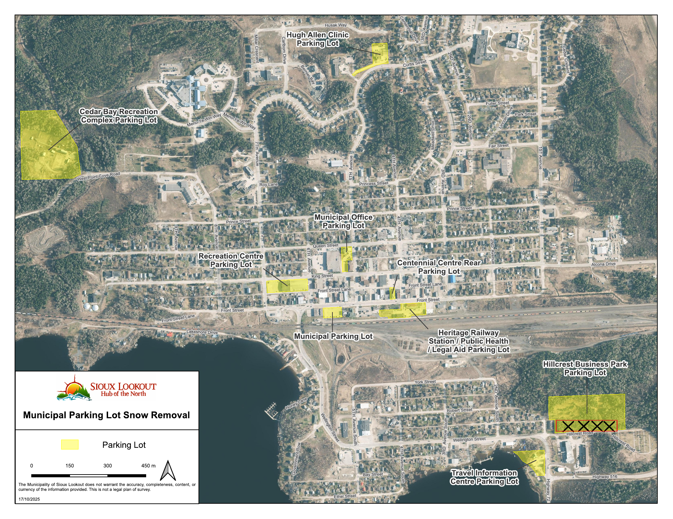
Hillcrest Business Park: only the upper parking lot and driveway/access corridor are included in the Work. The crossed-out lower area shown on the map is excluded unless specifically directed by the Municipality.

Appendix B - Service Part B Urban Roadway Inventory and Classifications
The classifications below are provided for winter-maintenance planning and MMS compliance. Operational clearing priorities and sequencing are established by the Municipality and Appendix C. Every municipally maintained urban back lane forms part of Part B, including unnamed or otherwise unlisted back lanes.
Urban Road or Back Lane | Class
First Avenue South (Wellington to By-Pass) | 3
Wellington Street | 3
Atwood Street | 4
Curtis Street (Fifth to Third Avenue) | 4
Eighth Avenue | 4
Fair Street | 4
Fifth Avenue North | 4
First Avenue North (Second to Atwood) | 4
Front Street (Third to Eighth Avenue) | 4
Highland Park | 4
King Street (First to Eighth Avenue) | 4
Seventh Avenue | 4
Third Avenue North | 4
Bay Street | 5
Birchwood Crescent | 5
Carlbom Drive | 5
Cedar Crescent | 5
Centennial Drive | 5
Curtis Street (Third to Second Avenue) | 5
Ethel Street | 5
Fifth Avenue South | 5
First Avenue (Front to King) | 5
Fourth Avenue North to Princess | 5
Fourth Avenue South | 5
Front Street (First to Third Avenue) | 5
Front Street (Eighth to Tenth Avenue) | 5
Fuller Street | 5
King Street (Eighth Avenue to STP) | 5
Lakeshore Drive | 5
Lincoln Drive | 5
May Street | 5
Meadwell Drive | 5
Mitchell Drive | 5
Montello Place | 5
Ninth Avenue (Prince to Queen) | 5
Prince Street | 5
Princess Street | 5
Queen Street | 5
Robert Street | 5
Second Avenue North | 5
Second Avenue South | 5
Sixth Avenue North | 5
Sixth Avenue South | 5
Third Avenue South | 5
Wide Street | 5
York Street | 5
OPP Back Lane | 5
Front Street Back Lane | 5
Fourth Avenue North of Princess | 6
Hannah Crescent | 6
High Street | 6
Hillcrest Road | 6
Lake Street | 6
Ninth Avenue (Queen to King) | 6
Park Street | 6
South Street | 6
Hoey Drive | 6
Back Lanes - All Others | 6

Routine Patrolling Frequency
Road Class | Routine Patrol Frequency
Class 3 | Once every 7 days
Class 4 | Once every 14 days
Classes 5 and 6 | Once every 30 days

Appendix C - Urban Snow Clearing Priority Routes and Maps
The following maps identify the Municipality's operational snow-clearing phases and routes and form part of the RFQ. Route sequencing may be revised by Municipal direction in response to public safety, emergency access, weather, drifting or operational conditions.

C1 - Phase I Urban Roads
The arterial and hospital route is to be completed first, followed by the remaining Phase I roads.
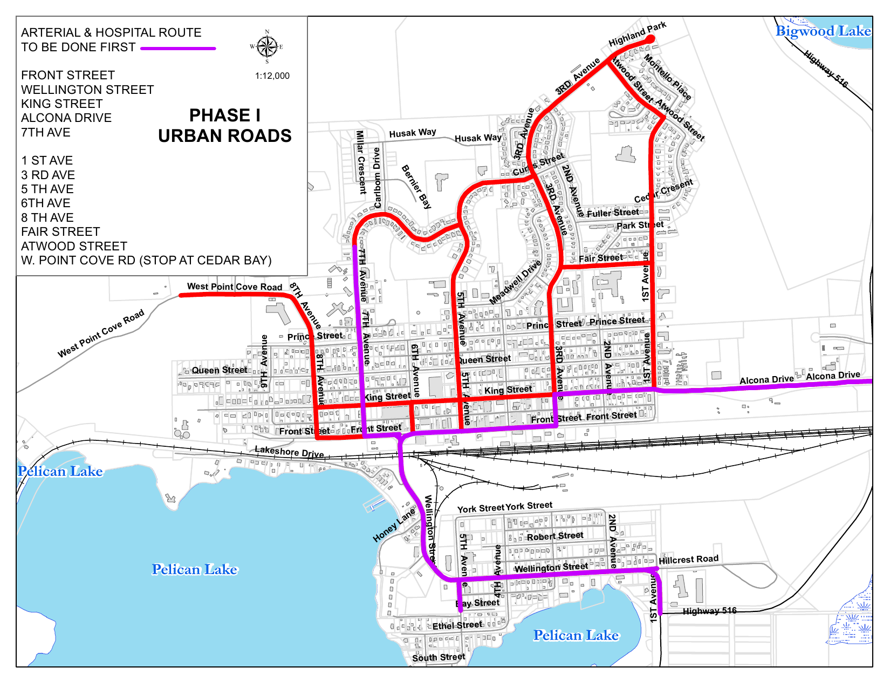

C2 - Phase II Northeast Urban Roads
Phase II Northeast road routes.
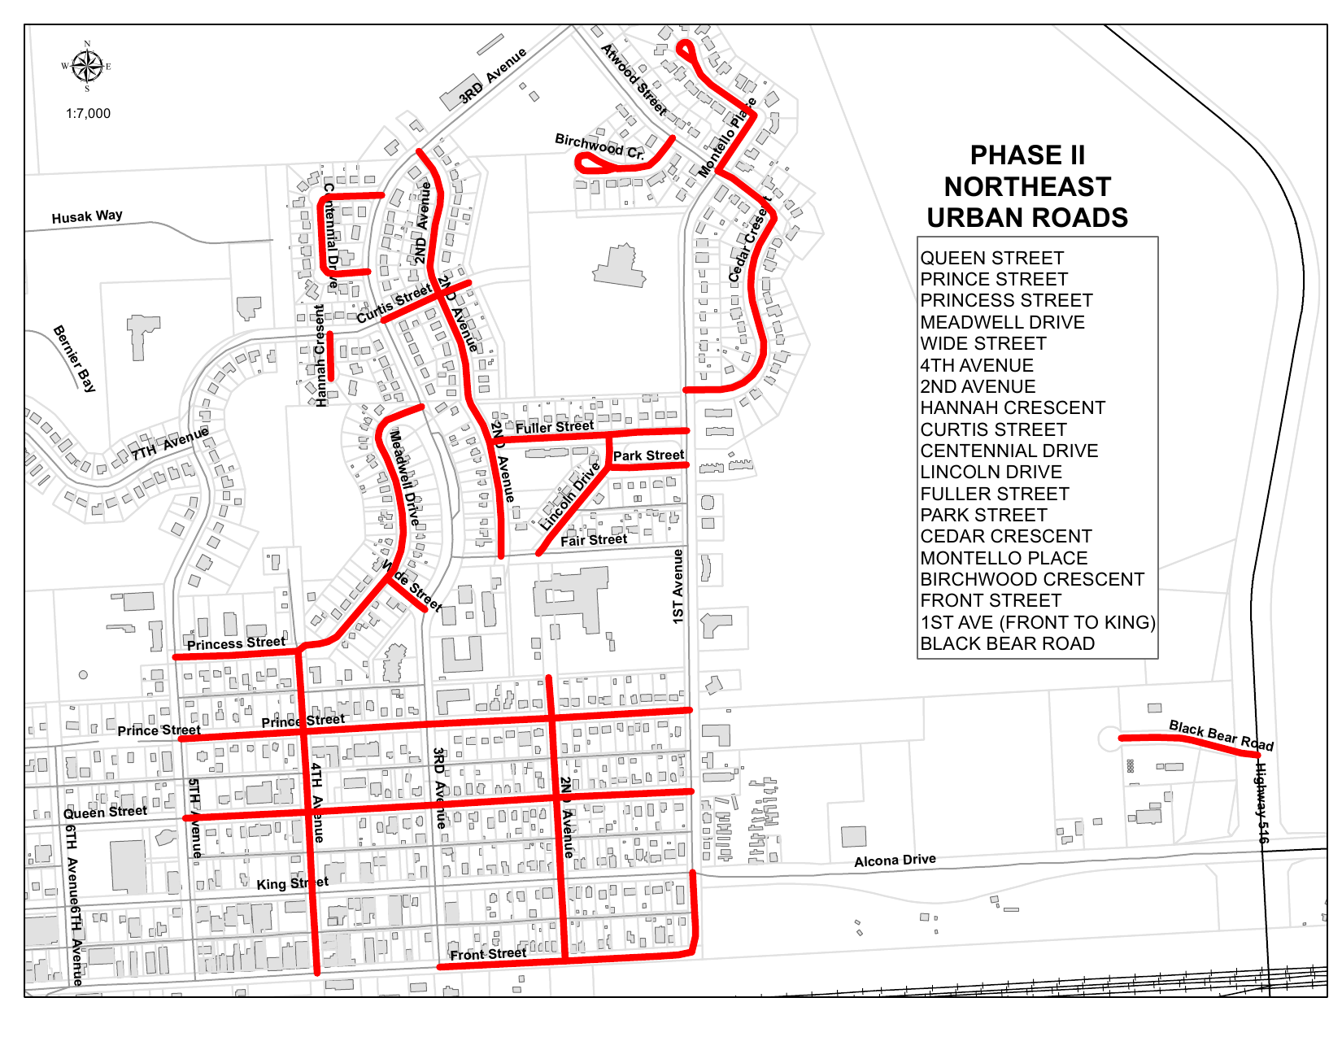

C3 - Phase II Northwest Urban Roads
Phase II Northwest road routes.
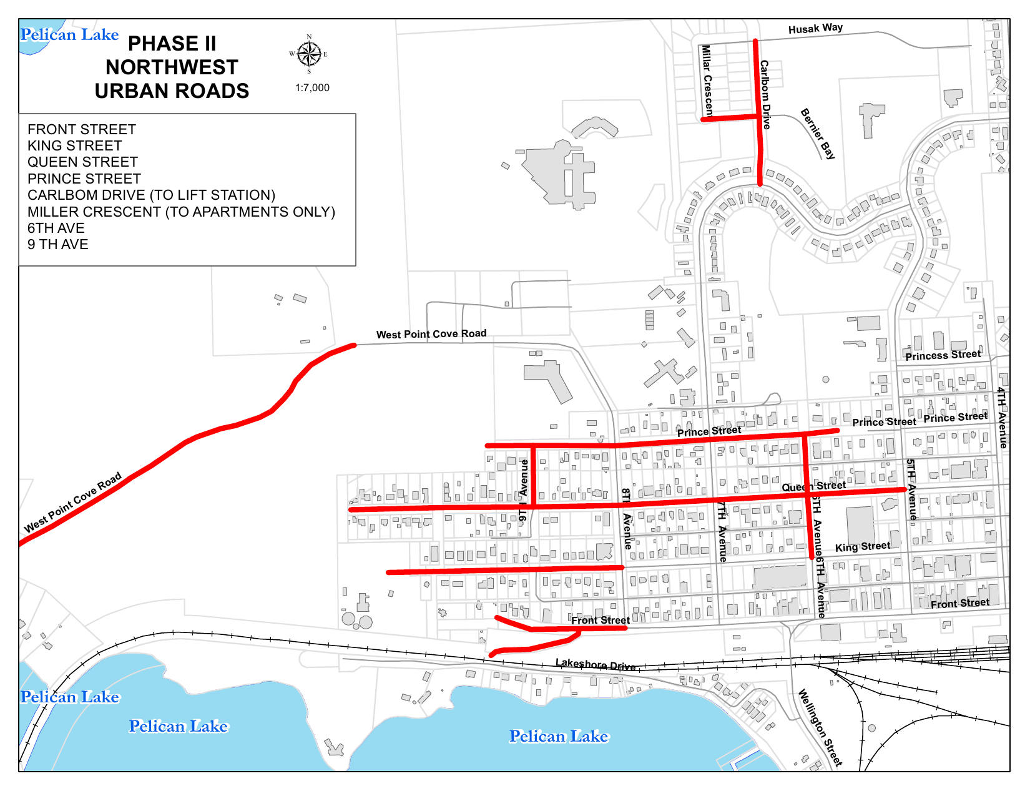

C4 - Phase II South Urban Roads
Phase II South Class 5 urban roads.
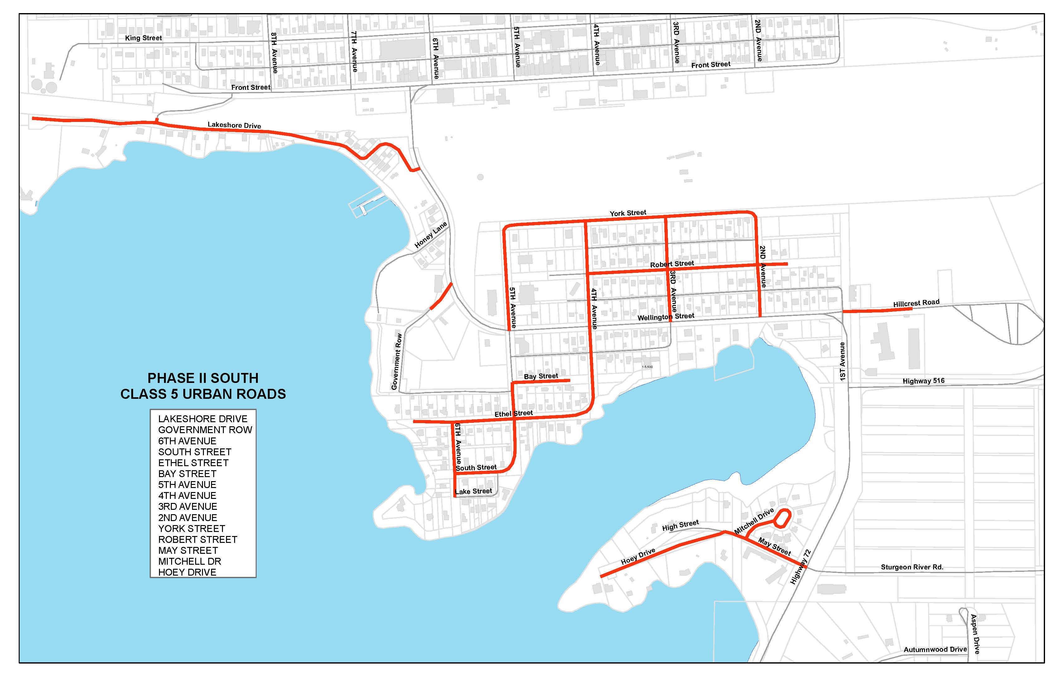

C5 - Phase III Northeast Urban Roads
Phase III Northeast routes. The map identifies priority back-lane work.
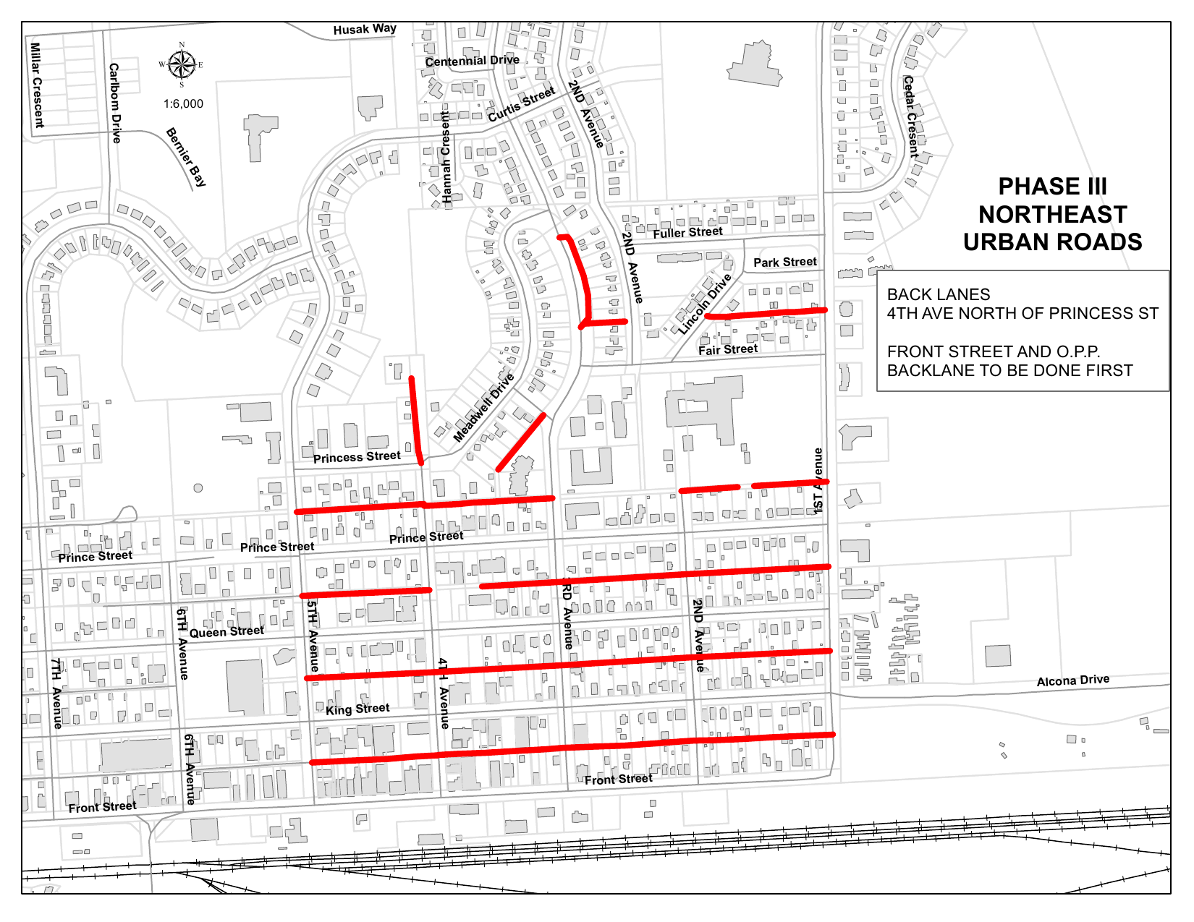

C6 - Phase III Northwest Urban Roads
Phase III Northwest routes. The map identifies priority back-lane work.
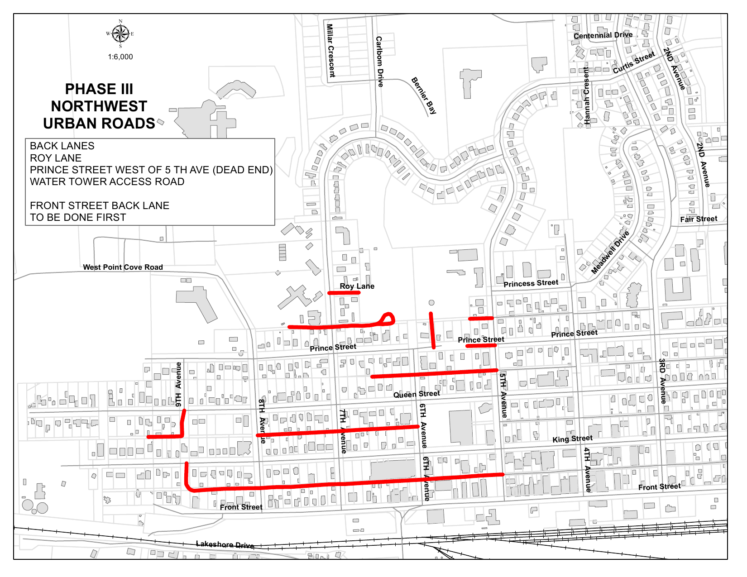

C7 - Phase III South Urban Roads
Phase III South routes, including the listed back lanes and extensions.
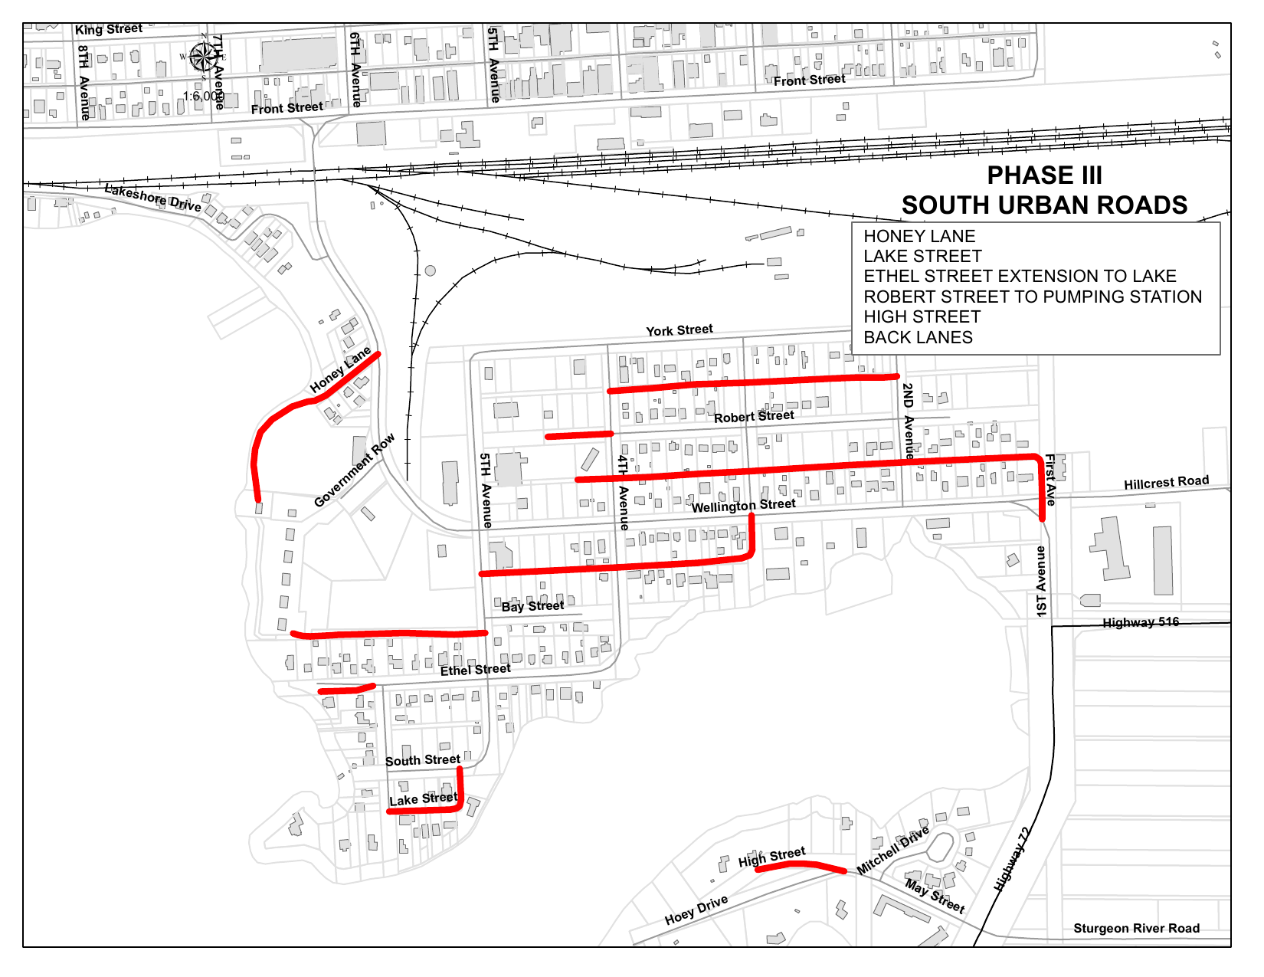

C8 - Phase III Cemetery Roads
Cemetery road routes for Sacred Heart Cemetery, Northway Cemetery and Hillcrest Cemetery.
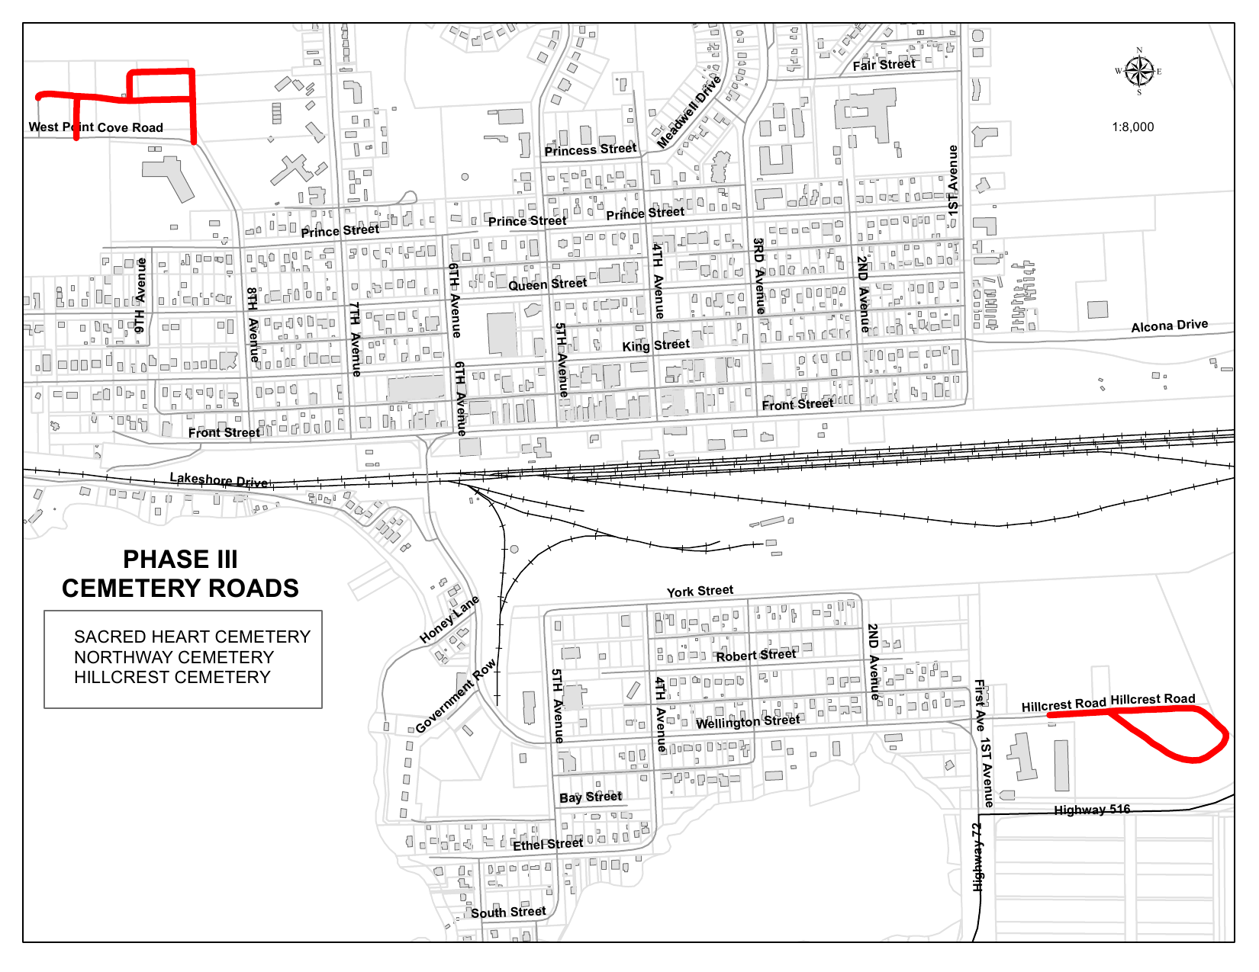

C9 - Phase One Sidewalk Snowplowing / Sanding
Phase One sidewalk route and sand-box locations.
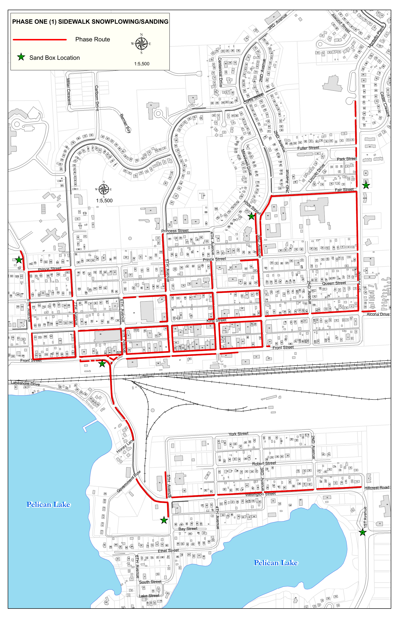

C10 - Phase Two Sidewalk Snowplowing / Sanding
Phase Two sidewalk route and sand-box locations.
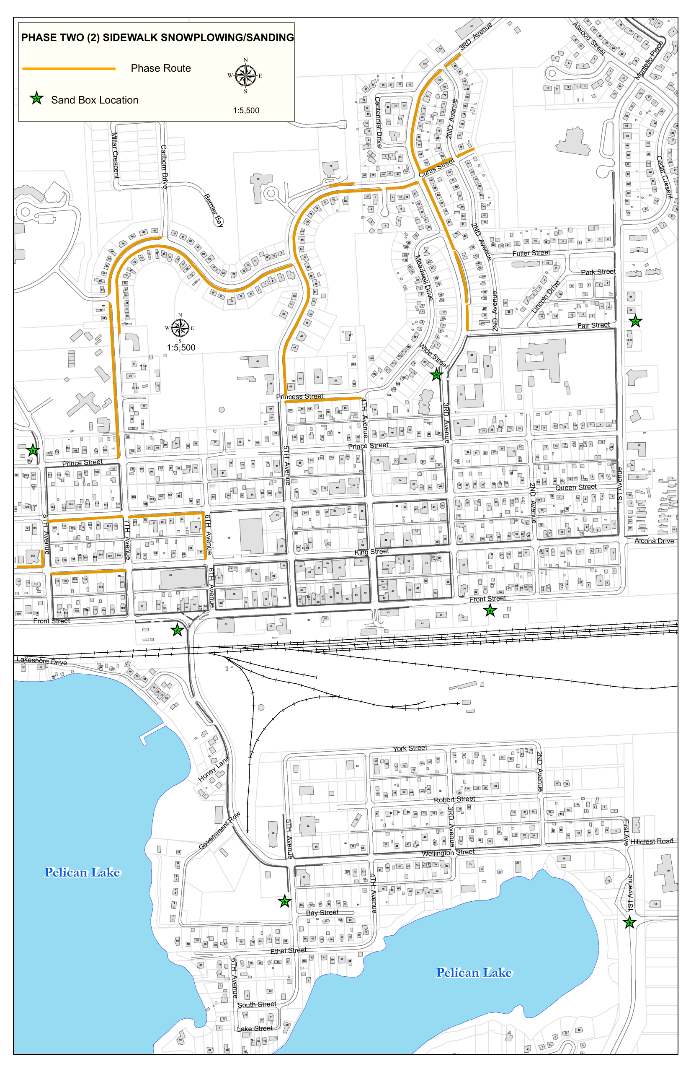

C11 - Phase Three Walking Trail Snowplowing / Sanding
Phase Three walking trail route and sand-box location.
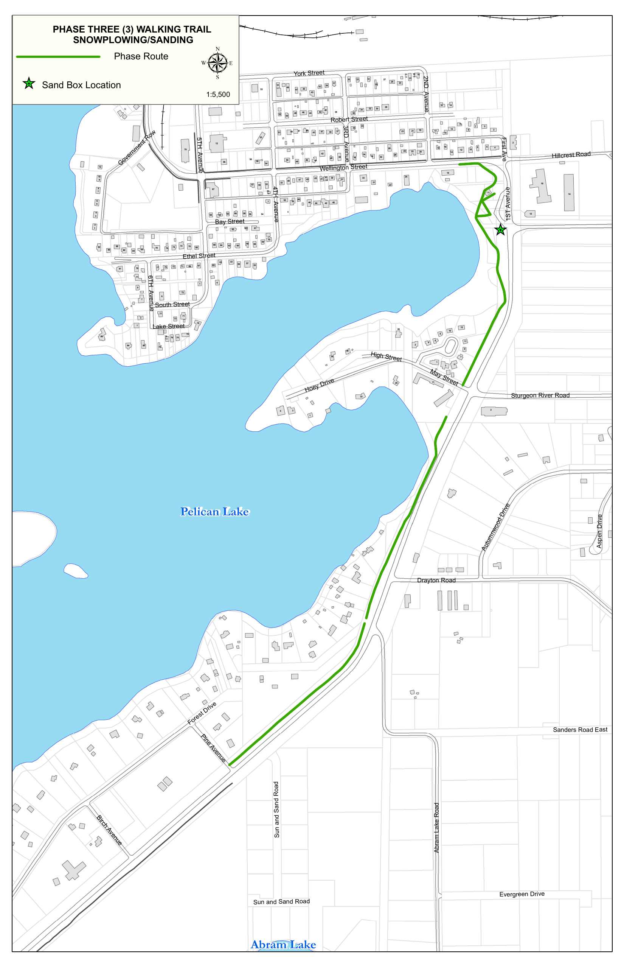

Appendix D - Mandatory Pricing Form
All prices exclude HST unless expressly stated otherwise. Bidders shall not modify the structure of this form. If an item is included elsewhere, state "Included" and identify where. If not applicable, state "N/A." All assumptions, exclusions and qualifications shall be listed in Appendix F.

D.1 Quotation Selection
The Bidder is submitting a quotation for: [ ] Part A Only [ ] Part B Only [ ] Parts A and B
Part A and Part B will be evaluated independently in accordance with Section 8.4. A Bidder may quote either Part or both Parts. If the same Bidder is selected for both Parts, the Municipality may award both Parts under one Services Agreement.

D.2 Part A - Municipal Parking Lots and Facilities
Facility or Service | Pricing Basis | Quoted Price CAD
Municipal Office / Town Hall - 25 Fifth Avenue | Per clearing event including sanding | $____________
Recreation Centre - 85 King Street | Per clearing event including sanding | $____________
Hugh Allen Clinic - 79 Fifth Avenue North | Per clearing event including sanding | $____________
Municipal Lot Adjacent to Red Apple - Front Street | Per clearing event including sanding | $____________
Heritage Railway Station - Station property | Per clearing event including sanding | $____________
Centennial Centre Rear - Community centre | Per clearing event including sanding | $____________
Travel Information Centre - Tourism office | Per clearing event including sanding | $____________
Hillcrest Business Park - Upper Lot & Driveway Corridor - Hillcrest Road | Per clearing event including sanding | $____________
Cedar Bay Recreation Complex - Cedar Bay | Per clearing event including sanding | $____________
Stand-alone sanding | Per facility visit or stated unit basis | $____________

D.3 Part B - Urban Snow Clearing
Service | Pricing Basis | Quoted Price CAD
Urban roads | Per full clearing event | $____________
All urban back lanes | Per full clearing event | $____________
Municipal sidewalks and pedestrian routes, including walking trail | Per full clearing event | $____________
Accessibility-program windrow removal | Per address or included | $____________
Loader for snowbank removal | Hourly | $____________
Snow-hauling truck with operator | Hourly | $____________
Snow blower or snow-removal unit | Hourly | $____________
Other approved equipment | Hourly | $____________

D.4 Optional Part B Sanding and Ice Control
Optional Part B sanding and ice control may be awarded with Part B or retained by the Municipality. Bidders proposing this optional service shall complete the pricing below. The Municipality may accept or decline the optional service without affecting the evaluation or award of the base Part B snow-clearing services.
Optional Sanding Service | Pricing Basis | Quoted Price CAD
Urban roads and back lanes | Per full sanding event | $____________
Sidewalks, pedestrian routes and walking trail | Per full sanding event | $____________
Approved material | Per tonne or included | $____________
Sanding unit with operator | Hourly | $____________

Appendix E - Equipment and Capacity Schedule
Identify all primary and backup equipment proposed for the Service Part or Parts submitted. For each unit, provide the make, model, year, capacity, primary or backup status, ownership or lease status, normal mobilization location and maximum mobilization time. If the table does not provide sufficient space for all required information or additional units, attach clearly labelled supplementary pages. The Municipality may require verification of availability, ownership or lease status, licensing, insurance and operating condition before award.
Equipment Category | Applicable Part | Minimum Requirement | Make / Model / Year / Capacity | Primary / Backup
Lot-clearing plow units | Part A | Sufficient for all facility timelines
Back-lane grader | Part B | Required
Main-road grader | Part B | Required; larger unit preferred
Loader | Parts A and B | Required for B; sufficient capacity for A
Sidewalk plow | Part B | Required
Sidewalk-capable snow blower unit | Part B | Required
Snow-hauling trucks | As awarded | Sufficient for directed work
Parking-lot sanding unit | Part A | Required
Road and back-lane sanding unit | Part B optional | Required only if awarded
Sidewalk sanding unit | Part B optional | Required only if awarded
Backup equipment | Parts A and B | Sufficient for uninterrupted service

Twenty-four-hour contact: ______________________________________________
Telephone: ______________________________ Alternate: ______________________________
Normal mobilization location: _________________________________________________
Maximum stated mobilization time: _____________________________________________

Appendix F - Quotation Response Schedule

F.1 Company and Contact Information
Legal name: ______________________________________________________________
Operating name, if different: ______________________________________________________________
Address: ______________________________________________________________
Primary contact: ______________________________________________________________
Telephone: ______________________________________________________________
Email: ______________________________________________________________
Years in business: ______________________________________________________________
Normal operating / mobilization location: ______________________________________________________________

F.2 Relevant Experience and References
No. | Client / Contract | Contact Information | Winter Services Performed
1
2
3

F.3 Winter Operations Plan
Attach a concise work plan addressing each item below. Cross-reference supporting documents where useful.
- mobilization and twenty-four-hour response arrangements;
- how the Appendix C route phases and Appendix A facility priorities will be staffed and sequenced;
- operator staffing, supervision, relief coverage and fatigue management;
- response during continuing or severe events and overlapping assignments;
- equipment breakdown and backup-resource plan;
- snowbank removal, hauling and disposal approach;
- communication with Municipal staff, complaint escalation and quality-control checks; and
- daily service records and GPS / automated vehicle-location capability, if available.

F.4 Assumptions, Exclusions, Qualifications and Subcontractors
List every assumption, exclusion or qualification that may affect price, service, risk, equipment, staffing or responsibility, and identify each proposed subcontractor and its intended work. If none, write "None."
No. | Assumption / Exclusion / Qualification / Subcontractor | Impact on Price, Schedule or Service
1
2
3
4
5

Appendix G - Form of Services Agreement
The following Form of Services Agreement will be completed with the successful Bidder. Bidders shall submit on the basis of these terms and identify all requested material exceptions in Appendix F.4. Administrative particulars, accepted Quotation commitments and non-material clarifications may be completed at award without changing the fundamental procurement or risk allocation.

SERVICES AGREEMENT - Snow Clearing and Sanding Services - RFQ No. Q033-2026

G.1 Parties and Effective Date
This Services Agreement (the "Agreement") is made effective __________________, 2026 between The Corporation of the Municipality of Sioux Lookout (the "Municipality") and ______________________________ (the "Contractor"). The Contractor is retained as an independent contractor to provide the awarded Services.

G.2 Awarded Services
[ ] Service Part A - Municipal Parking Lots and Facilities
[ ] Service Part B - Urban Snow Clearing
[ ] Optional Part B Sanding and Ice Control

G.3 Contract Documents and Order of Precedence
The Contract consists of the executed Agreement and amendments, RFQ addenda in reverse chronological order, this RFQ and its appendices, the accepted portions of the Contractor's Quotation including pricing and named resources, and written clarifications accepted before award. In the event of a conflict, the documents govern in the order listed above, except that a later written amendment expressly authorized by the parties governs the matter it addresses. The Contractor shall promptly notify the Municipality of any apparent conflict affecting safety, scope, price or service requirements and shall follow the Municipality’s written direction.

G.4 Term
The Initial Term begins on the effective date and continues through May 15, 2027 unless terminated earlier. Any extension is by mutual written agreement and subject to satisfactory performance, budget authorization and applicable procurement requirements.

G.5 Services and Standard of Performance
The Contractor shall continuously and diligently perform the awarded Work in accordance with the RFQ, applicable MMS, route maps, facility priorities, applicable law and accepted winter-maintenance practice. The Contractor shall provide all labour, supervision, equipment, backup equipment, fuel, communications and resources required for the awarded scope except items expressly allocated to the Municipality.

G.6 Equipment, Staffing and Backup
The Contractor shall maintain not less than the equipment, operator and backup commitments accepted in its Quotation. Proposed substitutions require prior Municipal approval and shall provide equal or better capability. The Contractor shall maintain qualified relief and backup resources so that breakdowns, absenteeism and foreseeable winter conditions do not materially interrupt service.

G.7 Direction, Records and Inspection
The Public Works Manager, Operations Supervisor or other designated Municipal representative may issue operational directions within the awarded scope. The Contractor shall maintain and provide the service records required by the RFQ. The Municipality may inspect the Work, equipment and records at any reasonable time. Inspection, direction or payment does not relieve the Contractor of responsibility for compliant performance.

G.8 Fees and Invoicing
The Municipality shall pay the accepted prices in Appendix D for authorized and satisfactorily completed Work. Invoices shall be submitted monthly with supporting service records. Payment terms are net thirty (30) days from receipt of a correct and undisputed invoice. HST treatment will follow the accepted pricing form.

G.9 Insurance, WSIB and Safety
The Contractor shall maintain the insurance and WSIB coverage required by Part 9 throughout the Term and shall provide evidence before commencement and on request. The Contractor is responsible for the health and safety of its workers and subcontractors and for compliance with applicable law and the safety requirements of this RFQ.

G.10 Damage and Indemnity
The Contractor shall promptly report and address damage arising from its operations in accordance with Part 5. To the fullest extent permitted by law, the Contractor shall indemnify and hold harmless the Municipality, its elected officials, officers and employees from third-party claims, losses, damages and costs to the extent caused by the Contractor's negligence, wilful misconduct or breach of Contract.

G.11 Default, Municipal Step-In and Termination
The Municipality may issue a performance notice or require corrective action for service-level failures, unsafe conditions, equipment or staffing deficiencies, missing records or other material non-compliance. Where delay or deficient performance creates an actual or potential public-safety risk, the Municipality may arrange alternate forces and recover reasonable costs caused by Contractor default. Termination rights are as set out in Part 9.

G.12 Subcontracting and Assignment
The Contractor shall not assign the Agreement or subcontract a material part of the Work without prior written Municipal consent. Consent does not relieve the Contractor of responsibility for performance, safety, insurance, WSIB, records or the acts and omissions of subcontractors.

G.13 Changes and Notices
A material change to scope, price or term is binding only if documented in writing and authorized by the parties. Formal notices shall be in writing and delivered by hand, registered mail or email with confirmation of receipt. Municipality notice address: 25 Fifth Avenue, PO Box 158, Sioux Lookout, Ontario, P8T 1A4. Contractor notice address: ______________________________.

G.14 Governing Law and General
The Agreement is governed by the laws of Ontario and applicable federal laws of Canada. The parties attorn to the jurisdiction of Ontario courts. A waiver is effective only in writing and only for the stated instance. If a provision is invalid or unenforceable, it shall be severed and the remainder continues in force. The Agreement may be executed in counterparts and by electronic signature.

G.15 Execution

THE CORPORATION OF THE MUNICIPALITY OF SIOUX LOOKOUT

Signature: _________________________________________ Date: __________________
Name: _____________________________________________
Title: ______________________________________________

CONTRACTOR: ________________________________________

Signature: _________________________________________ Date: __________________
Name: _____________________________________________
Title: ______________________________________________

Appendix H - Bidder Declaration, Addenda Acknowledgement and Submission Checklist

H.1 Addenda
Addenda acknowledged: [ ] None [ ] No. ______ [ ] No. ______ [ ] No. ______

H.2 Submission Checklist
[ ] Quotation placed in a sealed physical envelope or package and marked as required by Section 2.1
[ ] Bidder name and return address shown on the outer envelope or package
[ ] Completed Appendix D - Mandatory Pricing Form
[ ] Completed Appendix E - Equipment and Capacity Schedule
[ ] Completed Appendix F - Quotation Response Schedule
[ ] Relevant experience and references
[ ] Winter Operations Plan
[ ] Evidence of ability to obtain required insurance
[ ] Current WSIB clearance or commitment to provide before Work begins
[ ] Proposed subcontractors identified
[ ] Assumptions, exclusions, qualifications and requested Agreement exceptions clearly identified
[ ] Addenda acknowledged

H.3 Declaration
The undersigned, having authority to bind the Bidder, declares that the Bidder has reviewed the RFQ, appendices, route maps and issued addenda; has examined the scope and service requirements; has disclosed all assumptions, exclusions and exceptions; can provide the personnel, supervision, primary equipment, backup equipment and twenty-four-hour response capability proposed; and agrees that the Quotation may be accepted for Part A, Part B, both Parts, or the optional Part B Sanding and Ice Control service, but only for the services identified by the Bidder in Appendix D and below.

Bidder legal name: ______________________________________________________________
Operating name, if different: ______________________________________________________________
Address: ______________________________________________________________
Contact person / title: ______________________________________________________________
Telephone / email: ______________________________________________________________
Quotation submitted for: [ ] Part A [ ] Part B [ ] Parts A and B
Authorized signature: ______________________________ Date: __________________
Name and title of signing officer: ______________________________________________

